

OPERATING SYSTEMS

Process & Thread Monitoring



AUGUST 31, 2020

SRI RAMACHANDRA ENGINEERING & TECHNOLOGY M SATHISHKUMAR

Steps Involved in THREAD MONITORING

Downloading & Installing Process Explorer:

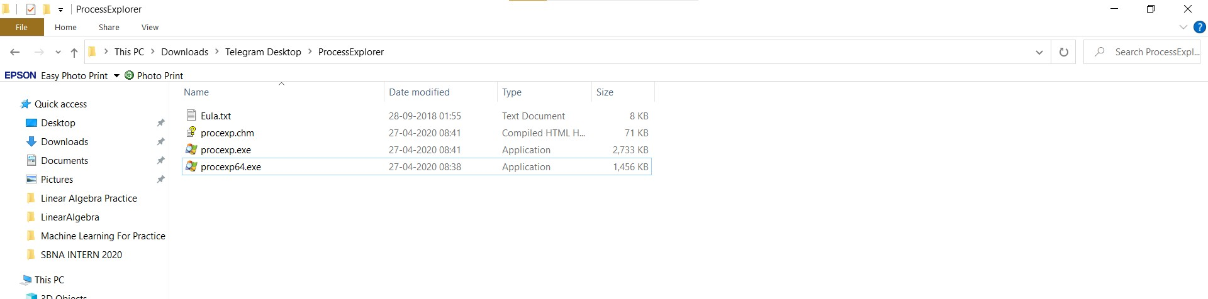

Download link : <https://docs.microsoft.com/en-us/sysinternals/downloads/process-explorer>

 Checking for processes running:

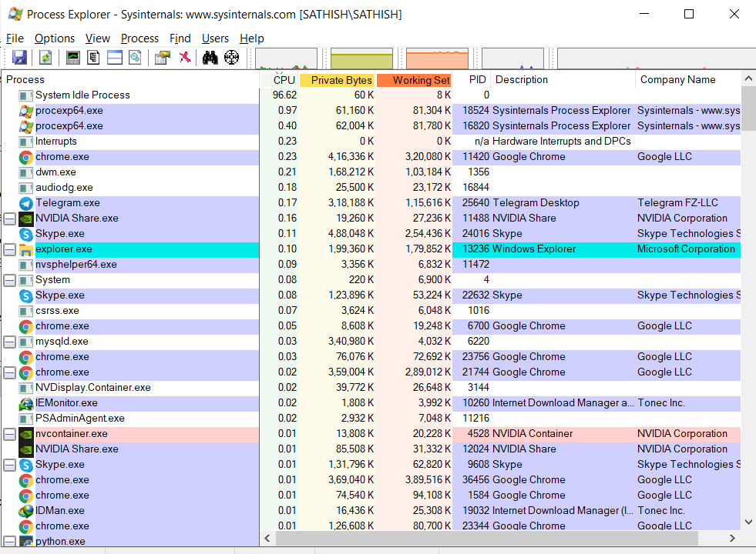

 Navigating to a specific process:

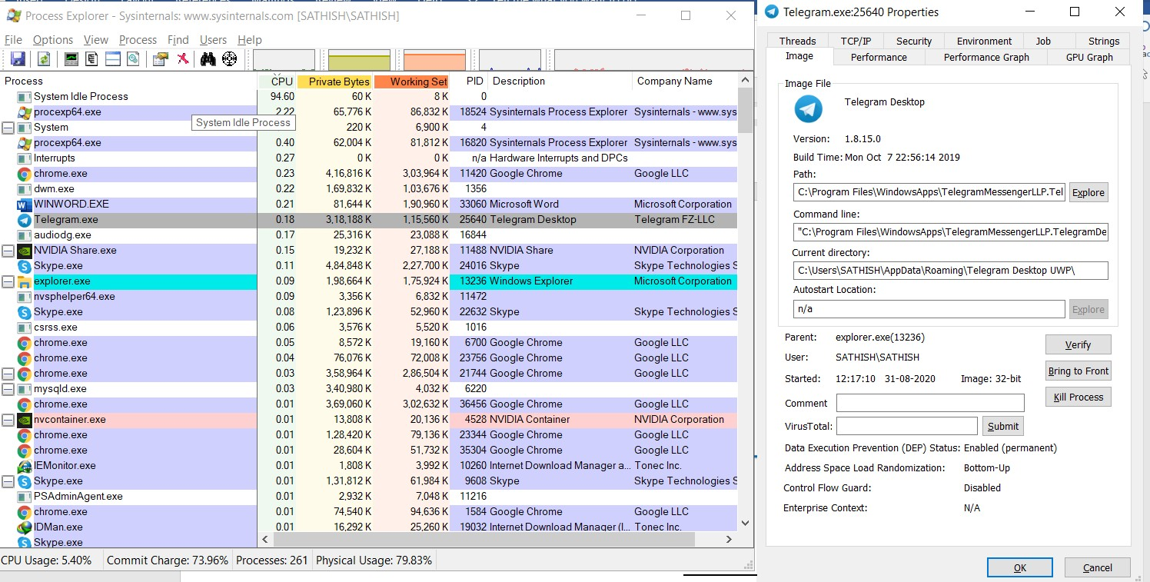

Thread Monitoring for that specific process:

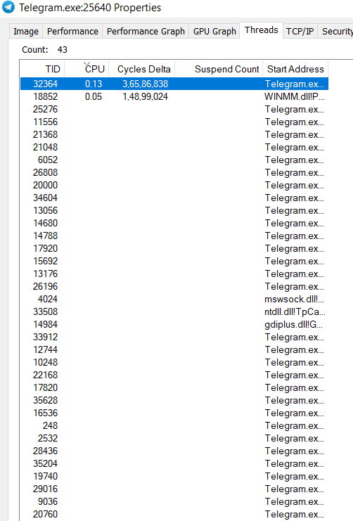

---- THANK YOU ----

X

M.Sathishkumar

Student